The Oracle Server
The Oracle Server is a relational database management system that provides an open, comprehensive, and integrated approach to information management. An Oracle Server consists of an Oracle database and an Oracle instance. The following sections describe the relationship between the database and the instance.

Structured Query Language (SQL)
SQL (pronounced SEQUEL) is the programming language that defines and manipulates the database. SQL databases are relational databases; this means simply that data is stored in a set of simple relations. A database can have one or more tables. And each table has columns and rows. A table that has an employee database, for example, might have a column called employee number and each row in that column would be an employee's employee number.
You can define and manipulate data in a table with SQL commands. You use data definition language (DDL) commands to set up the data. DDL commands include commands to creating and altering databases and tables.
You can update, delete, or retrieve data in a table with data manipulation commands (DML). DML commands include commands to alter and fetch dat. The most common SQL command is the SELECT command, which allows you to retrieve data from the database.
In addition to SQL commands, the Oracle Server has a procedural language called PL/SQL. PL/SQL enables the programmer to program SQL statements. It allows you to control the flow of a SQL program, to use variables, and to write error-handling procedures.

Database Structure
An Oracle database has both a physical and a logical structure. Because the physical and logical server structure are separate, the physical storage of data can be managed without affecting the access to logical storage structures.
Physical Database Structure An Oracle database's physical structure is determined by the operating system files that constitute the database. Each Oracle database is made of three types of files: one or more datafiles, two or more redo log files, and one or more control files. The files of an Oracle database provide the actual physical storage for database information.
Logical Database Structure An Oracle database's logical structure is determined by
- one or more tablespaces. (A tablespace is a logical area of storage explained later in this chapter.)
- the database's schema objects. A schema is a collection of objects. Schema objects are the logical structures that directly refer to the database's data. Schema objects include such structures as tables, views, sequences, stored procedures, synonyms, indexes, clusters, and database links.
The logical storage structures, including tablespaces, segments, and extents, dictate how the physical space of a database is used. The schema objects and the relationships among them form the relational design of a database.

An Oracle Instance
Every time a database is started, a system global area (SGA) is allocated and Oracle background processes are started. The system global area is a an area of memory used for database information shared by the database users. The combination of the background processes and memory buffers is called an Oracle instance. Figure 1 - 1 illustrates a multiple process Oracle instance.

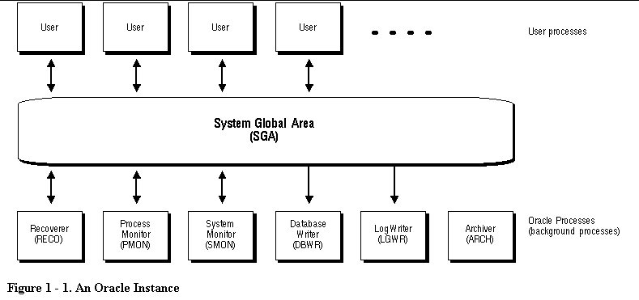
Ilustración 1

An Oracle instance has two types of processes: user processes and Oracle processes.
A user process executes the code of an application program (such as an Oracle Forms application) or an Oracle Tool (such as Server Manager).
Oracle processes are server processes that perform work for user processes and background processes that perform maintenance work for the Oracle Server.

Database Structure and Space Management
This section describes the architecture of an Oracle database, including the physical and logical structures that make up a database. This discussion provides an understanding of Oracle's solutions to controlled data availability, the separation of logical and physical data structures, and fine-grained control of disk space management.

Relational Database Management Systems
Database management systems have evolved from hierarchical to network to relational models. Today, the most widely accepted database model is the relational model. The relational model has three major aspects:

Structures
Structures are well-defined objects (such as tables, views, indexes, and so on) that store or access the data of a database. Structures and the data contained within them can be manipulated by operations.

Operations
Operations are clearly defined actions that allow users to manipulate the data and structures of a database. The operations on a database must adhere to a predefined set of integrity rules.

Integrity Rules
Integrity rules are the laws that govern which operations are allowed on the data and structures of a database. Integrity rules protect the data and the structures of a database.
Relational database management systems offer benefits such as
- independence of physical data storage and logical database structure
- variable and easy access to all data
- complete flexibility in database design
- reduced data storage and redundancy
An Oracle database is a collection of data that is treated as a unit. The general purpose of a database is to store and retrieve related information. The database has logical structures and physical structures.

Logical Database Structures
The following sections explain logical database structures, including tablespaces, schema objects, data blocks, extents, and segments.

Tablespaces
A database is divided into logical storage units called tablespaces. A tablespace is used to group related logical structures together. For example, tablespaces commonly group all of an application's objects to simplify certain administrative operations.
Databases, Tablespaces, and Datafiles The relationship among databases, tablespaces, and datafiles (datafiles are described in the next section) is illustrated in Figure 1 - 2.

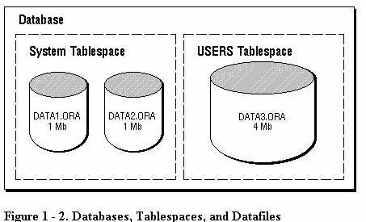

This figure illustrates the following:
- Each database is logically divided into one or more tablespaces.
- One or more datafiles are explicitly created for each tablespace to physically store the data of all logical structures in a tablespace.

Schemas and Schema Objects
A schema is a collection of objects. Schema objects are the logical structures that directly refer to the database's data. Schema objects include such structures as tables, views, sequences, stored procedures, synonyms, indexes, clusters, and database links.

Physical Database Structures
The following sections explain the physical database structures of an Oracle database, including datafiles, redo log files, and control files.

Datafiles
Every Oracle database has one or more physical datafiles. A database's datafiles contain all the database data. The data of logical database structures such as tables and indexes is physically stored in the datafiles allocated for a database.
The following are characteristics of datafiles:
- A datafile can be associated with only one database.
- Database files can have certain characteristics set to allow them to automatically extend when the database runs out of space.
- One or more datafiles form a logical unit of database storage called a tablespace, as discussed earlier in this chapter.
The Use of Datafiles The data in a datafile is read, as needed, during normal database operation and stored in the memory cache of Oracle. For example, assume that a user wants to access some data in a table of a database. If the requested information is not already in the memory cache for the database, it is read from the appropriate datafiles and stored in memory.
Modified or new data is not necessarily written to a datafile immediately. To reduce the amount of disk access and increase performance, data is pooled in memory and written to the appropriate datafiles all at once, as determined by the DBWR background process of Oracle. (For more information about Oracle's memory and process structures and the algorithm for writing database data to the datafiles.

Redo Log Files
Every Oracle database has a set of two or more redo log files. The set of redo log files for a database is collectively known as the database's redo log. The primary function of the redo log is to record all changes made to data. Should a failure prevent modified data from being permanently written to the datafiles, the changes can be obtained from the redo log and work is never lost.
Redo log files are critical in protecting a database against failures. To protect against a failure involving the redo log itself, Oracle allows a multiplexed redo log so that two or more copies of the redo log can be maintained on different disks.
The Use of Redo Log Files The information in a redo log file is used only to recover the database from a system or media failure that prevents database data from being written to a database's datafiles.
For example, if an unexpected power outage abruptly terminates database operation, data in memory cannot be written to the datafiles and the data is lost. However, any lost data can be recovered when the database is opened, after power is restored. By applying the information in the most recent redo log files to the database's datafiles, Oracle restores the database to the time at which the power failure occurred.
The process of applying the redo log during a recovery operation is called rolling forward.

Control Files
Every Oracle database has a control file. A control file contains entries that specify the physical structure of the database. For example, it contains the following types of information:
- database name
- names and locations of a database's datafiles and redo log files
- time stamp of database creation
Like the redo log, Oracle allows the control file to be multiplexed for protection of the control file.
The Use of Control Files Every time an instance of an Oracle database is started, its control file is used to identify the database and redo log files that must be opened for database operation to proceed. If the physical makeup of the database is altered (for example, a new datafile or redo log file is created), the database's control file is automatically modified by Oracle to reflect the change.
A database's control file is also used if database recovery is necessary.

